DATA ANALYTICS WITH TABLEAU

ASSIGNMENT-4

**Task-1:** Create one fixed and one exclude LOD expression

* 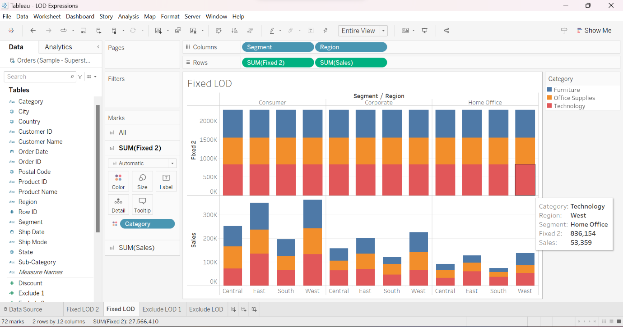FIXED LOD
* The above visualization is Stacked bars visualization.
* In this visualization FIXED LOD is used.
* Formula used in this LOD is:

{FIXED [Category]: SUM([Sales])}.

* The above visualization defines the total Sales in fixed “Category” in each segment and region.
* The SUM[Sales] = 27,566,410.
* EXCLUDE LOD

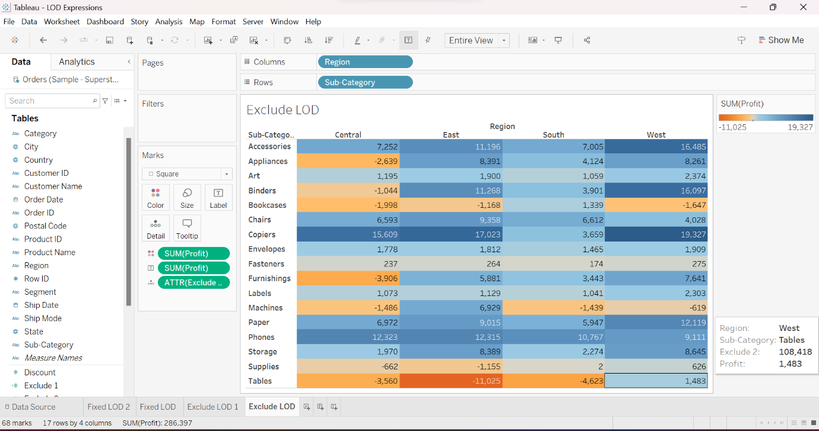

* The above visualization represents the tree maps visualisation.
* In this visualization EXCLUDE LOD is used.
* Formula used in this LOD is:

{EXCLUDE [Sub-Category]: SUM([Profit])}.

* The above visualization defines the total profit and the profit is excluded for sub-categories in each region.
* The SUM[Profit]=286,397.

**TASK-2**: Create any 2 map visualizations using geographical data

* HEAT MAP

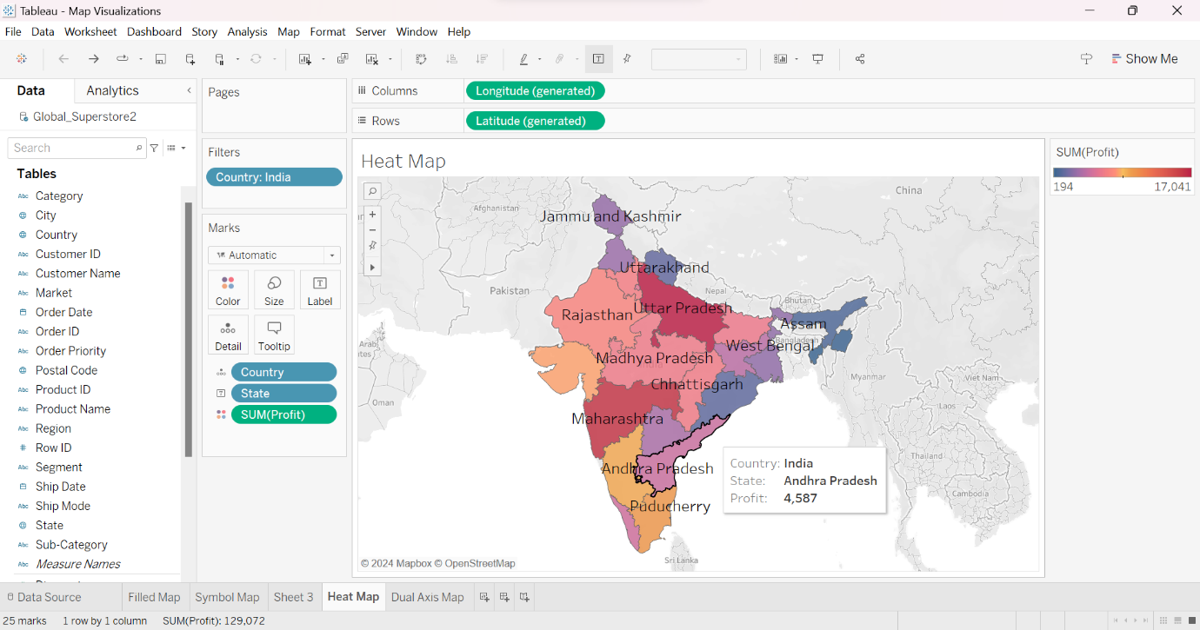

* The above visualization represents the Heat map visualization.
* The visualization represents the profits in different states in India.
* The different colours represent different states with the total profits.
* By highlighting each state, the profit of that particular state will be visible as shown in the visualization.
* The SUM[Profit]=129,072.
* DUAL AXIS MAP

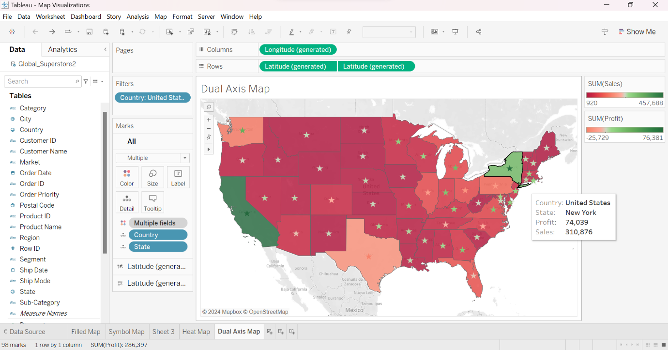

* The above visualization represents the Dual axis map visualization.
* The visualization represents the total sales and total profits in different states of United States.
* The different coloured shapes represent the total sales in different states of United States and the symbols represents the total profits in different states of United States.
* By highlighting each state, the sales and profit of that particular state will be visible as shown in the above visualization.
* The SUM[Profit]=286,397.

**TASK-3:** Create Top N and /or Dynamic dimension parameters and utilise those in your workbook

* TOP N PARAMETER

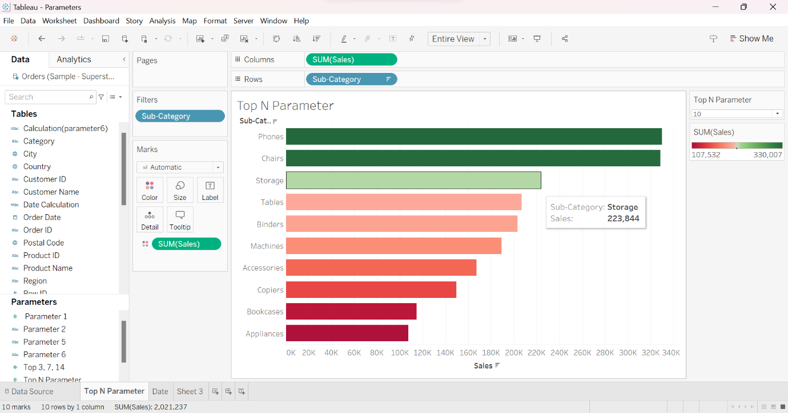

* This visualization represents horizontal bars.
* In this visualization, we have represented the sales of different sub-categories.
* We have used a parameter in this visualization known as TOP N parameter which is created by the user. This parameter also gives us the access to change the display of bars of the number of sub-categories to be displayed.
* We have created a set to display the total sub-categories.
* By using this set, we can select the sub-categories which are to be highlighted only them.
* In the above visualization, we have selected the top 10 sub-categories of sales.
* We can change the number in the Top N parameter visible on the visualization.